**EXPERIMENT-12**

***Title:*** 12. To understand the concepts of Trigger.

***Objective:*** Students will be able to implement the concept of trigger.

***Theory:***

In SQL, triggers are special types of stored procedures that are automatically executed or fired in response to certain events occurring in the database. These events can include INSERT, UPDATE, or DELETE operations on specific tables. Triggers are useful for enforcing data integrity, auditing changes, or performing additional actions based on database events.

***SYNTAX:***

CREATE [OR REPLACE] TRIGGER trigger_name

{BEFORE | AFTER | INSTEAD OF} {INSERT | UPDATE | DELETE}

ON table_name

[REFERENCING OLD AS old NEW AS new]

[FOR EACH ROW]

WHEN (condition)

BEGIN

-- Trigger body (SQL statements)

END;

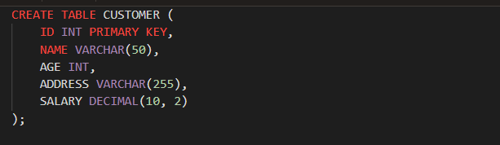

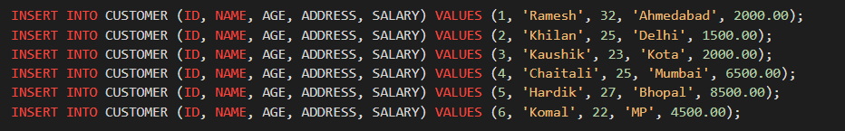

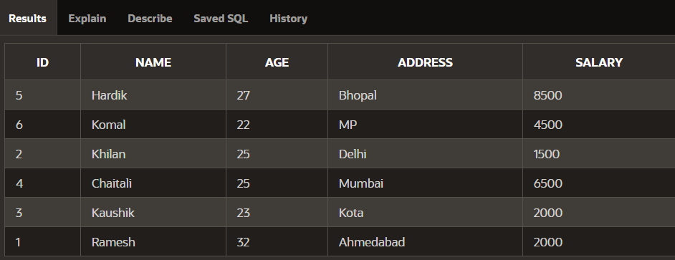

1. Create a row level trigger for the customers table that would fire for INSERT or UPDATE or DELETE operations performed on the CUSTOMERS table. This trigger will display the salary difference between the old values and new values.

